N
New Faculty Academic Affairs Orientation
2019-2020
Monday, August 19, 2018
Hartness Pavillion

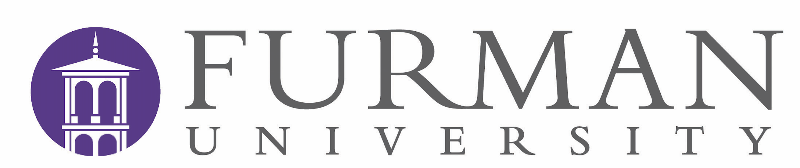

Pre-Reading for colleagues: https://www.facultyfocus.com/articles/teaching-careers/advice-for-new-faculty-six-lessons-from-the-front-lines/

8:30 Continental Breakfast

9:00 Opening remarks, welcome, and short overview of Furman faculty life (Provost Ken Peterson)

9:20 Dean’s Welcome (Interim Dean Suzy Summers)

9:30 Supporting Student Success (Associate Academic Dean Jeremy Cass)

9:45 Crowd Sourcing Your Questions: Academic Programs, Syllabi, First Day Strategies (Associate Dean for Faculty Development Diane Boyd and Jeremy Cass)

10:15 Coffee break

10:30 President’s welcome (Elizabeth Davis)

11:00 Getting to Know our Students (Dean of Students Jason Cassidy)

11:20 Interactive Case Studies: Where do I go for Help? (Jeremy Cass and Diane Boyd)

12:00 Lunch with faculty mentor groups, and academic leaders

1:00 Student Walking Tours with Faculty

1:30 Pro-Tips: Academic Regulations and Teaching (Jeremy Cass and Diane Boyd)

2:30 Q & A with Colleagues

3:15 Closing Remarks (Jeremy Cass)

6:00 Dinner and optional tasting at the Community Tap (217 Wade Hampton Boulevard)

