3-2-1

Basic Strategy
The 3-2-1 format is a quick reflective activity similar to think-pair-share. It encourages students to reflect on a course experience and organize their thoughts and identify areas of confusion or concern.

Why would you use it?
Similar to minute papers, muddiest point, and think-pair-share, the 3-2-1 Format can be a helpful tool for getting students to organize their thoughts, and promote reflection and metacognition. This activity provides an easy way to check for understanding and gauge student interest. It is also an effective way to promote discuss or review material.

When can you use it?
This activity would traditionally be introduced toward the end of a lesson or after a lecture. It could also be used in response to an assigned reading.

How does it work?
In reaction to presented content, students are asked to take a few moments and jot down:
- 3 ideas or issues from what was presented
- 2 example or uses for how the ideas could be implemented
- 1 unresolved area / muddiest point
Students are then asked to share their ideas in pairs or small groups. Use the responses to help guide teaching decisions. Consider areas of curriculum that need to be reviewed again or specific concepts or activities that are most interesting for students.

Alternative versions
- Use 3-2-1 Format to transition into class discussion.
- Student can complete 3-2-1 as individuals, pairs, or small groups.
- Make the 3-2-1 questions content specific (differences, similarities, etc.)
- Have students focus 3-2-1 on main ideas (most important ideas, supporting details, etc.)

Online options
3-2-1 Format could easily be adapted into an online discussion board activity.

Concept mapping
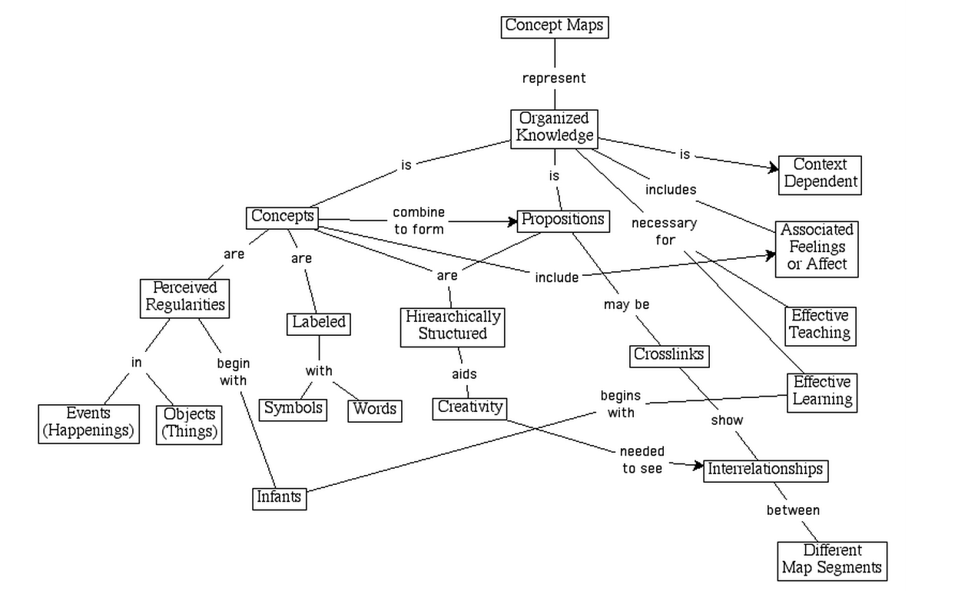

Why would you use it?
This activity provides an observable action of the student’s patterns of understanding related to a central idea or concept. Concept mapping serves several purposes:
- Helps students brainstorm and generate new ideas
- Encourages students to discover new concepts and the propositions that connect them
- Allows students to more clearly communicate ideas, thoughts and information
- Helps students integrate new concepts with older concepts
- Enables students to gain enhanced knowledge of any topic and evaluate the information

When can you use it?
Concept maps require a lot of cognitive work on the part of the student, and a lot of preparation and analysis on the part of the instructor. Be sure you have tested the concept map activity yourself and given the class the appropriate amount of time to complete the activity. Usually this means twice the amount of time it took you, the expert, to complete. This activity is useful in any course with high theoretical content, courses with large amounts of facts and principles.

How does it work?
- Select the concept/theme you wish students to use as a starting point.
- Create a concept map:
  - Identify related key words or phrases. Write down words and key phrases.
  - Rank the concepts (key words) from the most abstract/general to the most concrete/specific.
  - Cluster concepts that function at similar level of abstraction and those that interrelate closely. Start to determine the ways the various concepts are related to each other and write that on the lines connecting the concepts.
  - Arrange concepts into a diagram.
  - Continue identifying the ways the various concepts are related to each other and write that on the lines connecting the concepts.
- Add second and third level associations, if appropriate.
- Good maps usually result from three to many revisions.
- After students have completed the concept maps, present your own example to the students and walk through it with them step-by-step, explaining your thinking as you created the concept map.
Important Consideration for Using Concept Maps
- Concept mapping can be a very demanding cognitive task for students.
- Concept maps requires a large amount of time and energy from faculty to formally assess; concept maps are generally not graded.
- Large classes may be managed easier if concept map assignments are assigned to small groups
Best Practices for Using Concept Maps:
- Create your own concept map first, before assigning one to your students.
- If students are new to concept maps, students will need training and continual practice. Together as a class, create a simple concept map on a concept everyone is familiar wit. For example, use an easy topic like, “What are birds?”

Alternate versions
- Use a top down approach, working from general to specific or use a free association approach by brainstorming nodes and then develop links and relationships.
- Assign a concept map as a small group activity to alleviate anxiety.
- Extend the activity by having students write an explanatory essay based on their maps.
- Construct a concept map and then remove all of the concept labels (keep the links!). Ask students to replace the labels in a way that makes structural sense.
- Create a concept map and then remove concepts from the nodes (about one-third of them). These deleted concepts are placed in a numbered list on the map and students choose among them.
- Provide a list of concept labels (10 to 20) and ask students to construct their maps using only these labels. The focus here is on the linking relationships, and the evolution of structural complexity of students' knowledge frameworks.

Memory Matrix

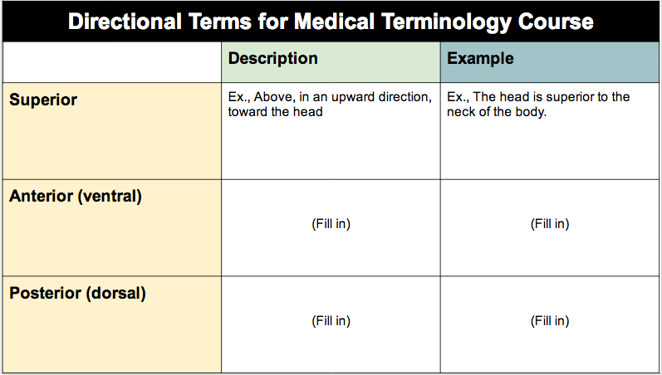

Basic strategy
Memory Matrix is a simple, two-dimensional table divided into rows and columns. The table is used to organize information and identify relationships in the content. Some cells in the table are intentionally left blank where students are asked to fill in the blank cells, demonstrating their understanding of the content. There is moderate investment of time required on behalf of faculty to create the matrix and then analyze the results.

Why would you use?
The technique provides a structure for students to organize and synthesize complicated information. This exercise works well with large amounts of content and can simplify complex, dynamic systems of information. Faculty can identify prior or incorrect knowledge.

When can you use?
Memory matrix is simple to implement and easy to use during instruction however there is some up-front preparation that must be completed. Consider content carefully. Content needs to appropriately align with column and row organization. This exercise is effective after lectures, videos, reading assignments, etc.

How does it work?
1. Carefully choose your content topic. Make sure the content can be organized in a table with rows and columns.
2. Create a simple matrix. Make one completed matrix to use as a key. This will make the analysis much easier. Also create a blank matrix for students to fill in.
3. Explain the purpose of the exercise.
4. Let students know how much time they will have, what kinds of responses you are looking for (words, bullets, short sentences), and when they can expect feedback.
5. Handout blank or partially filled matrix. Have students work on in class, individually or in groups. Provide practice matrices or examples if this is the first time you are presenting a memory matrix.
6. Students complete the matrix and hand-in.
7. Review and analyze results
- Analysis: Scan the completed matrices and compare to your key matrix. correct responses vs incorrect responses - focus on patterns in the responses.
- Results: Record the number of each correct or incorrect response into an Excel spreadsheet (or any data management system) where data can be reported in a variety of methods. Look for common misconceptions or errors. This could indicate recall problems, difficultly categorizing information, or insufficient teaching focus on a particular topic or category.
8. Provide feedback and clear misconceptions at next class meeting

Alternative versions
- Cells can be manipulated in any number of ways. For instance, leave the cells blank or fill the cells in and leave the column heading blank.
- Matrix can be completed by individuals, in pairs, small teams, as a class.

Online options
- Use Google Spreadsheet to have small groups, or individuals fill cells.

